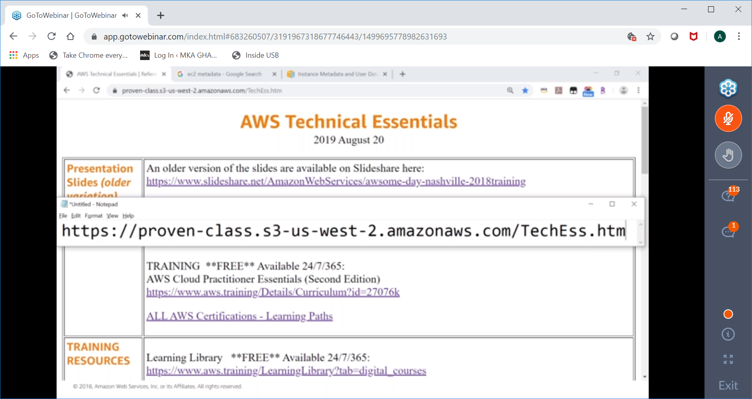

https://proven-class.s3-us-west-2.amazonaws.com/TechEss.htm

